### **Statistical Analysis of Social Network Usage Patterns**

### **Abstract**

This project investigates social network usage patterns and their potential impact on users' daily lives and mental health. Data were collected from 52 respondents via a Google Forms survey, covering variables such as age, time spent on social networks, primary purposes, and mental health effects. The study employed Python for statistical analysis and data visualization, including descriptive statistics, distribution analysis, and graphical representation. Key findings reveal that the majority of respondents are aged 18-24 years, with Instagram being the most popular social network. Most respondents spend 1-4 hours daily on social media, and some report feelings of dependency or occasional stress related to their usage. The study highlights the importance of understanding social network behavior to improve mental health awareness and guide further research. Limitations include a small sample size and potential response biases.

### **Introduction**

Social networks have become integral to daily life, connecting people across the globe and providing platforms for communication, information sharing, and entertainment. As the use of social media grows, it is increasingly important to understand how individuals interact with these platforms and the potential effects on their well-being. This study focuses on analyzing the usage patterns and preferences of social network users, aiming to uncover trends in demographics, time spent, and impacts on mental health.

The objective of this research is to investigate the most popular social networks, understand usage habits, and explore the relationship between social media use and factors like dependency and stress. The data for this study were collected via a Google Forms survey, where 52 participants provided responses to questions about their favorite platforms, daily usage, purposes for engaging with social networks, and perceived mental health effects.

The analysis utilizes statistical techniques and Python-based tools to generate insights. By combining descriptive statistics with graphical visualizations, this study seeks to highlight the dynamics of social network usage and its implications for users' daily lives. The findings aim to inform further research and promote awareness of social media’s impact on mental health.

### **Methods**

#### **Data Collection**

Data were collected using a Google Forms survey designed to gather information about respondents' social network usage habits. The survey included multiple-choice and open-ended questions covering:

* Age group.
* Favorite social network platforms.
* Average daily time spent on social networks.
* Primary purpose of using social networks.
* Dependency and stress levels related to social media usage.
* Perceived impact on mental health.

A total of 52 responses were received, forming the basis for statistical analysis. The survey was designed to ensure anonymity and encourage honest responses.

#### **Statistical Analysis**

The data were analyzed using Python and its associated libraries:

* **Descriptive Statistics**: Basic measures, such as frequency counts, were calculated for categorical data.
* **Distribution Analysis**: Histograms and box plots were used to examine the distribution of age groups and daily time spent.
* **Graphical Representation**: Bar charts and box plots were generated to visualize patterns in responses.
* **Correlation Analysis (if applicable)**: Relationships between variables, such as time spent and stress levels, were explored.

#### **Tools Used**

The following Python libraries were employed for data processing and analysis:

* **pandas**: For data manipulation and cleaning.
* **matplotlib** and **seaborn**: For creating detailed visualizations.
* **scipy**: For statistical calculations, including correlation analysis.

### **Results**

The results of this study are based on the analysis of the collected survey data. Each subsection presents key findings along with appropriate visualizations.

#### **1. Age Distribution**

The survey revealed that the majority of respondents were aged **18-24 years**, making up 73% of the sample. Other age groups, such as **25-34 years** and **Under 18 years**, had significantly fewer respondents, highlighting a younger demographic's active engagement with social networks.

**Figure 1:** Age Distribution of Respondents.  
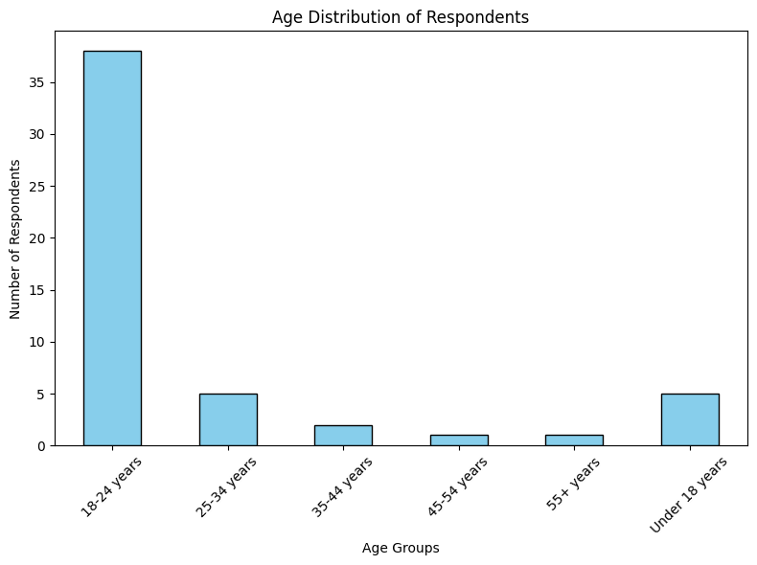

#### **2. Daily Time Spent on Social Networks**

Respondents reported varying amounts of time spent on social networks daily:

* **1-2 hours**: 35% of respondents.
* **2-4 hours**: 38% of respondents.
* **Less than an hour**: 12% of respondents.
* **4-6 hours**: 10% of respondents.
* **More than 6 hours**: 5% of respondents.

The results suggest that most users spend moderate amounts of time (1-4 hours) daily on social networks.

**Figure 2:** Frequency of Time Spent Intervals on Social Networks.

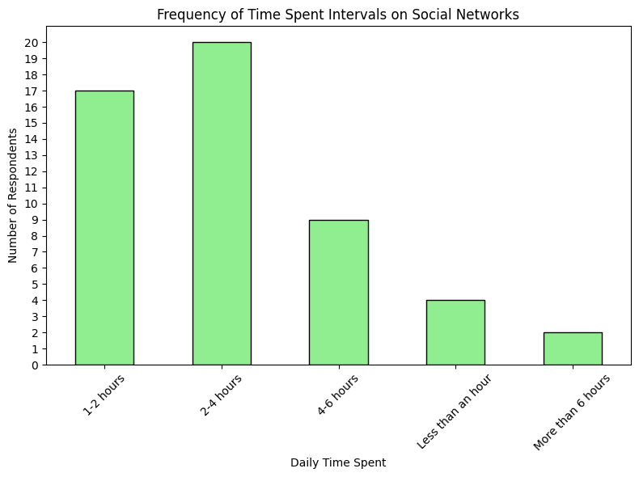

**Figure 3:** Box Plot of Daily time spent on Social Network.

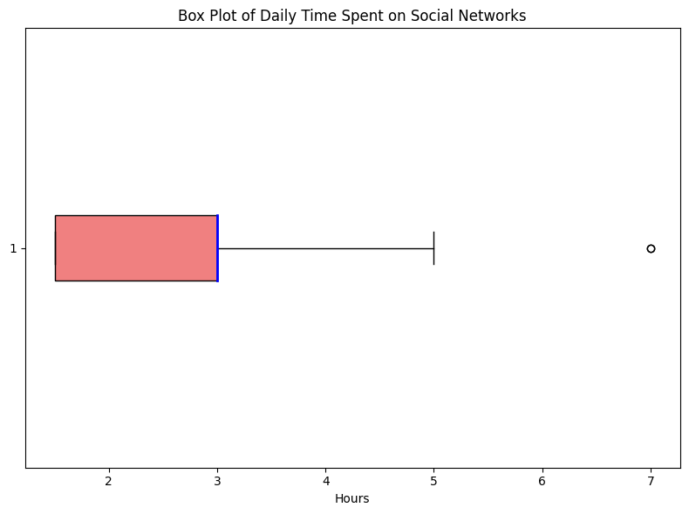

#### **3. Favorite Social Networks**

The survey identified **Instagram** as the most popular social network among respondents, followed by **Facebook** and **WhatsApp**. Platforms like **VK** and **Telegram** had fewer users.

**Figure 4:** Frequency of Favorite Social Networks

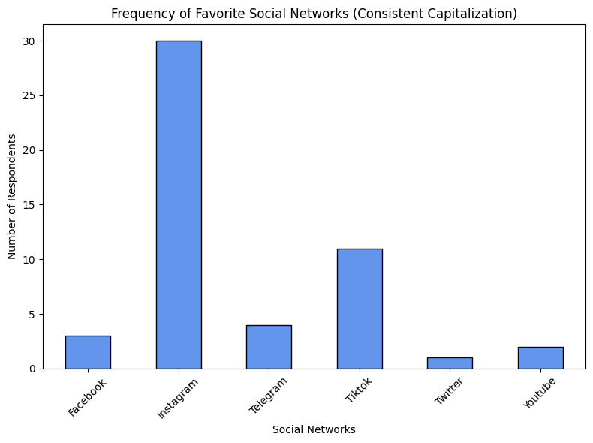

#### **4. Dependency and Stress Levels**

* **Dependency**: Around 60% of respondents reported feeling "Sometimes" dependent on social networks, while 30% claimed they did not feel dependent at all.

**Figure 5:** Dependency on Social Network.

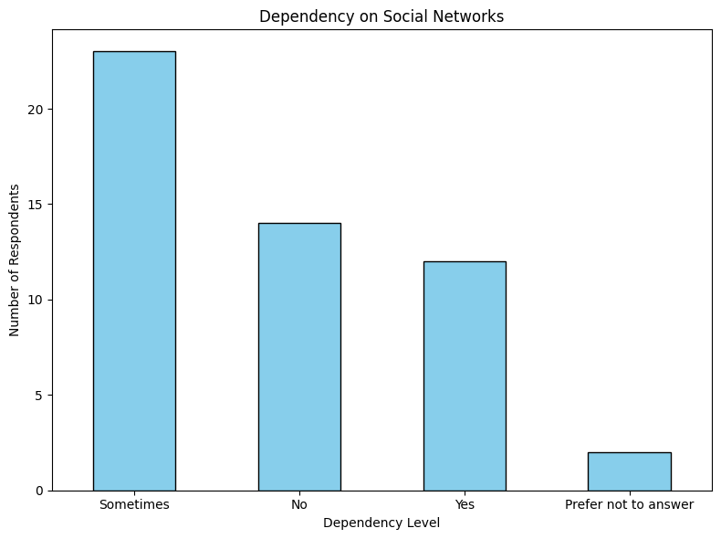

* **Stress**: Most respondents (50%) reported "Never" or "Rarely" experiencing stress due to social networks, while 25% reported occasional stress.

**Figure 6:** Stress experienced due to Social Networks

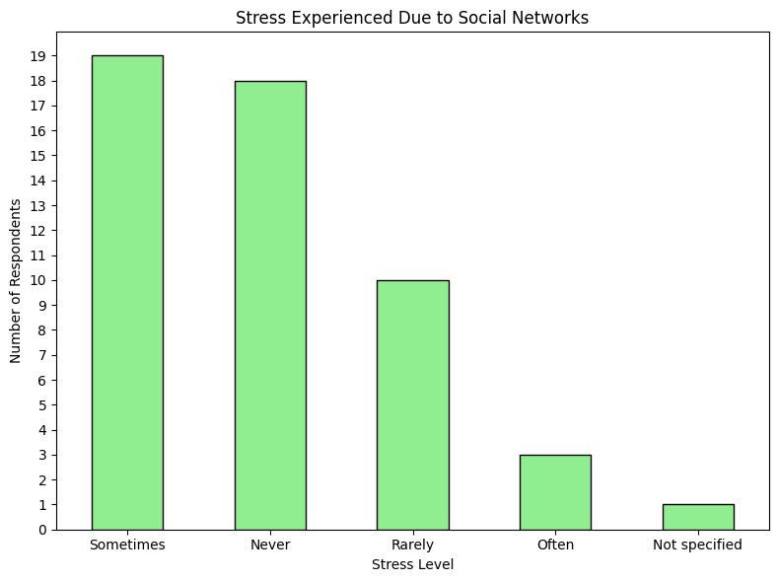

**Interpretation**: While dependency is a recurring theme, stress appears less prevalent among respondents.

#### **5. Perceived Impact on Mental Health**

* **Neutral**: 50% of respondents reported a neutral impact of social networks on their mental health.
* **Somewhat Positive**: 30% indicated a positive influence.
* **Somewhat Negative**: 15% indicated negative effects.

This suggests that, for most users, social networks are neither strongly beneficial nor harmful but have some influence on mental well-being.

**Figure 7:** Mental health impact distribution.

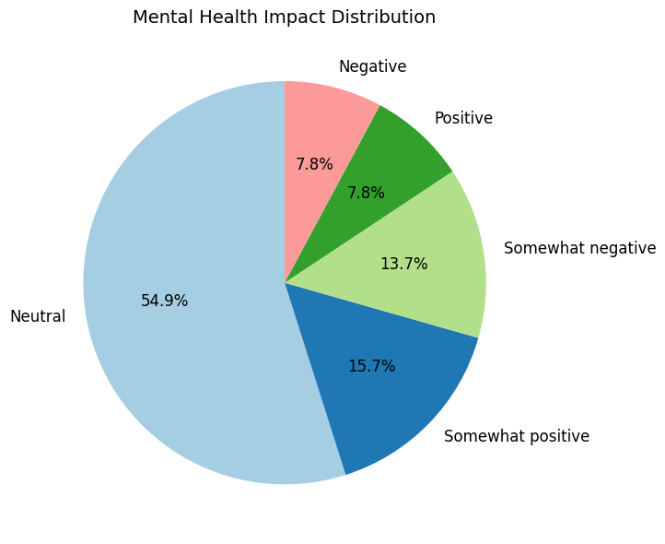

### **Discussion**

The results of this study highlight several important insights into social network usage patterns and their perceived effects on mental health.

#### **1. Dependency on Social Networks**

The findings show that while social networks play a significant role in users' daily lives, dependency levels are moderate for most respondents. Approximately 60% reported feeling "Sometimes" dependent on social networks, while 30% indicated no dependency at all. This suggests that while social media usage is habitual, many users do not view it as a necessity. For those experiencing occasional dependency, this may indicate the platform's importance for maintaining social connections or accessing information.

#### **2. Stress and Mental Health**

Interestingly, stress levels associated with social network usage are relatively low. The majority of respondents reported that they "Never" or "Rarely" experience stress due to social media. This may reflect users' ability to regulate their social media consumption or avoid triggering content. However, about 25% of users experienced occasional stress, which suggests that specific factors, such as negative interactions, overwhelming content, or unrealistic social comparisons, may influence stress levels.

The mental health impact distribution further supports this observation:

* Over half (54.9%) of respondents reported a neutral impact of social media on their mental health.
* About 15.7% indicated a somewhat positive effect, suggesting that social networks can provide support, entertainment, or meaningful engagement.
* On the other hand, 7.8% experienced negative impacts, highlighting the potential risks associated with social media, such as anxiety or reduced self-esteem.

#### **3. Popularity of Social Networks**

Instagram emerged as the most favored platform, with a significant number of respondents selecting it as their favorite. This reflects Instagram's ability to engage users through visual content and interactive features like stories and reels. TikTok was also popular, particularly among younger users, suggesting a preference for short-form, entertaining content. Platforms like Facebook and YouTube had a smaller but steady user base, reflecting their continued relevance.

#### **4. Recommendations**

Based on the findings, the following recommendations can be made:

1. **Promoting Digital Literacy**: Educating users on managing their screen time and avoiding addictive patterns can help reduce dependency.
2. **Encouraging Positive Interactions**: Platforms should focus on promoting positive content and minimizing negative interactions to reduce stress.
3. **Balancing Content**: Users should be encouraged to consume a balanced mix of entertaining, educational, and social content for better mental well-being.

#### **Limitations**

This study has some limitations:

* **Sample Size**: The small number of respondents (52) may not fully represent the diverse experiences of social media users.
* **Self-Reporting Bias**: Responses may be influenced by participants' self-perception or desire to present themselves positively.

Future research could address these limitations by including a larger sample size and exploring specific user demographics, such as age, occupation, or geographic location.

### **Conclusion**

This study provides valuable insights into social network usage patterns and their perceived effects on users’ mental health. The analysis highlights the moderate dependency levels on social networks, with the majority of respondents reporting occasional reliance on these platforms. Despite this, stress levels associated with social media use remain relatively low, suggesting that most users are able to manage their interactions effectively.

The study also reveals the dominant role of platforms like Instagram and TikTok, reflecting users’ preference for visually engaging and short-form content. While social networks have the potential to positively impact mental health by providing support and entertainment, a small but notable proportion of users reported negative effects. This underscores the need for strategies to promote healthier social media habits and mitigate risks such as stress or anxiety.

Moving forward, it is important to raise awareness about responsible social media usage and empower users with tools to balance their digital consumption. Future studies should aim to explore these patterns on a larger scale, incorporating diverse demographics and focusing on specific aspects of social network use, such as content types or user engagement.

In conclusion, while social networks play a vital role in modern life, it is essential to foster a balanced approach to maximize their benefits while minimizing potential harm.

### **References**

1. Python Software Foundation. (2023). *Python Programming Language*. Retrieved from<https://www.python.org/>
2. McKinney, W. (2010). *pandas: Data manipulation in Python*. Retrieved from https://pandas.pydata.org/
3. Hunter, J. D. (2007). *Matplotlib: Data visualization in Python*. Retrieved from<https://matplotlib.org/>
4. Waskom, M. L. (2021). *Seaborn: Statistical visualization library*. Retrieved from https://seaborn.pydata.org/
5. Virtanen, P., et al. (2020). *SciPy: Scientific computing tools*. Retrieved from<https://scipy.org/>
6. Google Forms. (2023). *Online survey platform*. Retrieved from<https://forms.google.com/>